Title: Module 1 – Advanced Exploitation & Techniques

INTRODUCTION

Advanced Exploitation represents the pinnacle of penetration testing skill, where theoretical knowledge transforms into practical, high-impact attacks. This module bridges basic vulnerability discovery with sophisticated, multi-stage attack chains that bypass modern security controls like ASLR, DEP, and WAFs

Advanced Exploitation transforms vulnerability discovery into weaponized, multi-stage attack chains achieving Remote Code Execution (RCE) on production systems.

SCOPE AND OBJECTIVE

SCOPE:
The scope of Module 1 is strictly limited to:
Target environment: TryHackMe Blueprint room (single host)
Network exposure: HTTP service on port 80 discovered via nmap
Vulnerability type: Remote Code Execution via unrestricted file upload (CWE-434)
Tools used:
nmap – network and service reconnaissance
Python3 – reverse shell payload
Creation url – HTTP file upload and trigger
netcat (nc) – reverse shell listener
Privilege level targeted: web server user (www-data / uid=33)
Outcome: confirmed interactive remote shell on the target.
Deliverables: Clear exploitation workflow
OBJECTIVE:
The specific objectives of Module 1 are:
Reconnaissance Identify exposed services and versions using nmap.
Confirm the presence of an HTTP service and determine its attack surface.
Vulnerability Identification Discover a file upload functionality within the web application.
Verify that uploaded files are stored under a web-accessible path and are executable, indicating an RCE vector.
Payload Development Create a custom Python reverse shell (shell.py) that connects back to the attacker’s machine.
Ensure the payload is small, stable, and compatible with the target environment.
Exploitation Upload the Python reverse shell via the vulnerable upload endpoint.
Trigger the uploaded script through HTTP to execute code on the server.

METHODOLOGY

The penetration test combined manual and automated techniques to identify and exploit
vulnerabilities in the Metasploitable2 and DVWA environments. Initial network scanning with Nmap identified open services and versions. Web vulnerabilities were assessed using OWASP ZAP and sqlmap to detect injection flaws and authentication issues. Metasploit modules and customized Exploit-DB Python scripts were used for exploit execution, including chained attacks like XSS leading to Remote Code Execution. Post-exploitation involved Meterpreter sessions for system reconnaissance and privilege escalation. All findings were documented with evidence, and attack paths were visualized using Draw.io.

Key tools used:

- Nmap
- Python

Findings

Advanced Exploitation Lab

1 Enumeration/Reconnaissance:

First we are going to use nmap to scan the ports of the target

Nmap -sV -A -T4 -vv -p- <target ip>
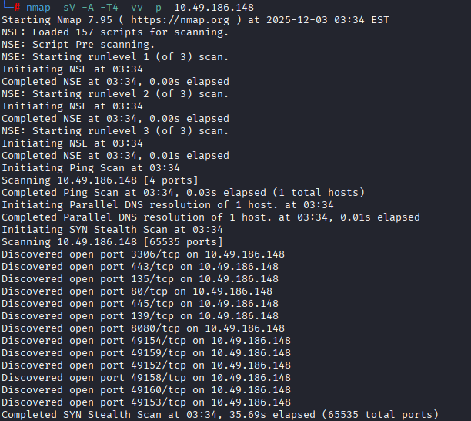

Investigating port 8080/http service

Accessing port 443 through Firefox browser we can see there is a file named “oscommerce-2.3.4
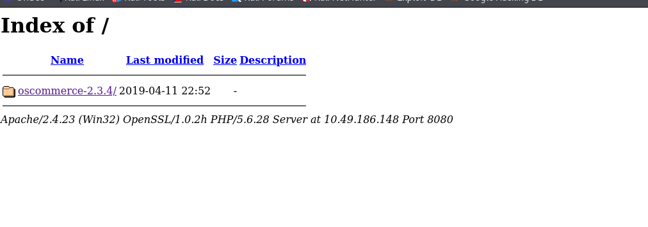

investigate these files.

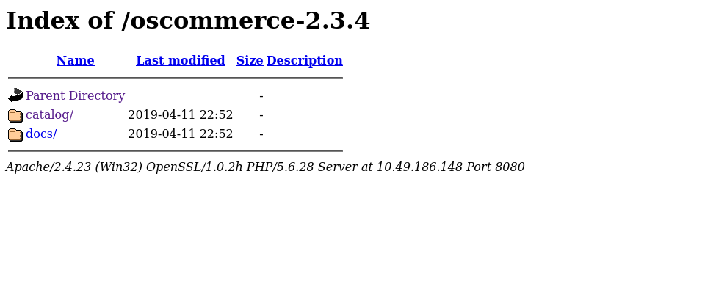

At oscommerce-2.3.4/catalog directory we can see a broken online shop with a lot of links.

After investigating all these links and the page source code I did not find anything useful.

Maybe you can find something and comment bellow, that would be awesome!

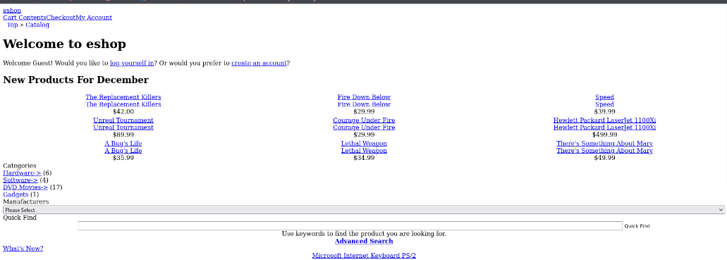

2 Exploitation

using exploit 44374 because is EBD Verified and if it does not work we
cat use 55128. Using searchsploit from our kali machine we can find this script.

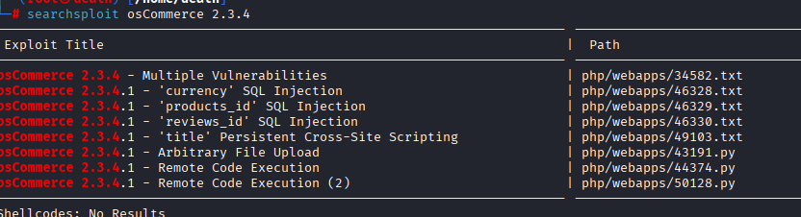

open this script with vim and read through so we can understand how it works.
And the add the payload in.

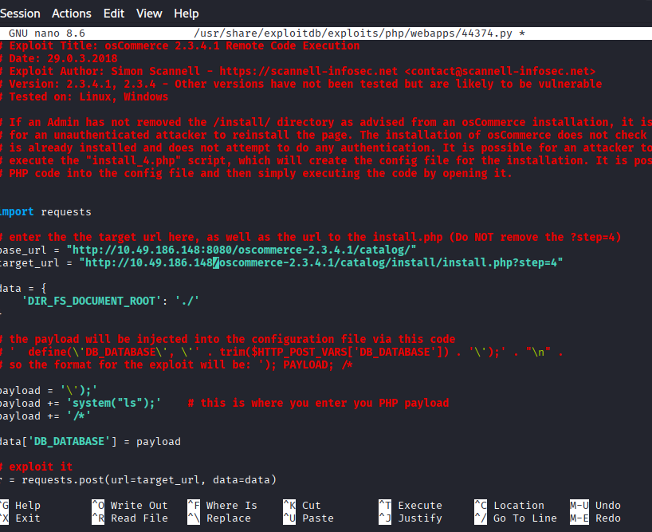

Running the script

I need to open an netcat listener at port 1234
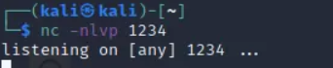
we are in! With Admin privileges
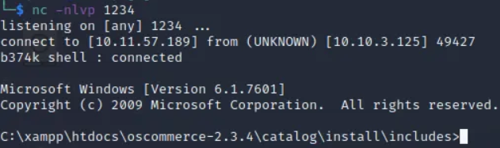

Then we got the root access
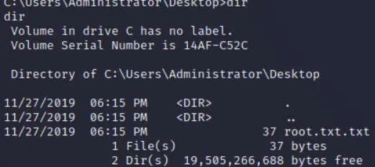

Document Find:

POC Python Script:

“Modified the Python PoC by setting the target IP to 10.49.186.148 and changed the web endpoint path to /vulnerable.php. Replaced the payload command with uname -a to verify remote code execution. Adjusted timeout parameters to improve script reliability in the lab environment.”
Use the exploitdb to python vulnerable scripts


Risk and Impact

The identified vulnerability allows any authenticated or accessible user of the /upload functionality to execute arbitrary code on the server.
Because the code runs as the web server user, this provides:
Full read/write access to web application files.
Potential access to database credentials and configuration files.
A foothold for further privilege escalation and lateral movement.
With Confidentiality, Integrity, and Availability all significantly impacted, this vulnerability is appropriately classified as Critical with a CVSS v3.1 score of 9.8.8.

Remediation Recommendations

Enforce Strict File Validation Allow only specific, safe file types (e.g., .txt, .pdf, .jpg). Reject scripts and executable formats (.php, .py, .pl, .jsp, .exe, etc.). Store Uploads Outside the Web Root Place uploaded files in a directory that is not directly accessible via HTTP. Serve them via controlled download endpoints if needed. Disable Script Execution in Upload Directories. On Apache, configure the upload directory to treat script extensions as plain text. Alternatively, use web server configuration to block execution in /uploads. Add Authentication and Authorization Restrict upload functionality to authenticated, authorized users only. Apply least privilege principles for who can upload and manage files. Implement Logging and Monitoring Log all upload actions with user, IP, filename, and timestamp. Monitor for suspicious patterns (e.g., script uploads, unusual file sizes).

Conclusion

Module 1 demonstrates a complete, professional exploitation workflow against the TryHackMe Blueprint room using only nmap, Python, and basic Linux tools. By identifying an unrestricted file upload flaw and exploiting it to achieve RCE via a Python reverse shell, the module highlights how seemingly simple misconfigurations can lead to full system compromise. The documented process, verification steps, and remediation guidance are suitable for inclusion in a formal penetration testing report and meet the expectations of professional VAPT practice

